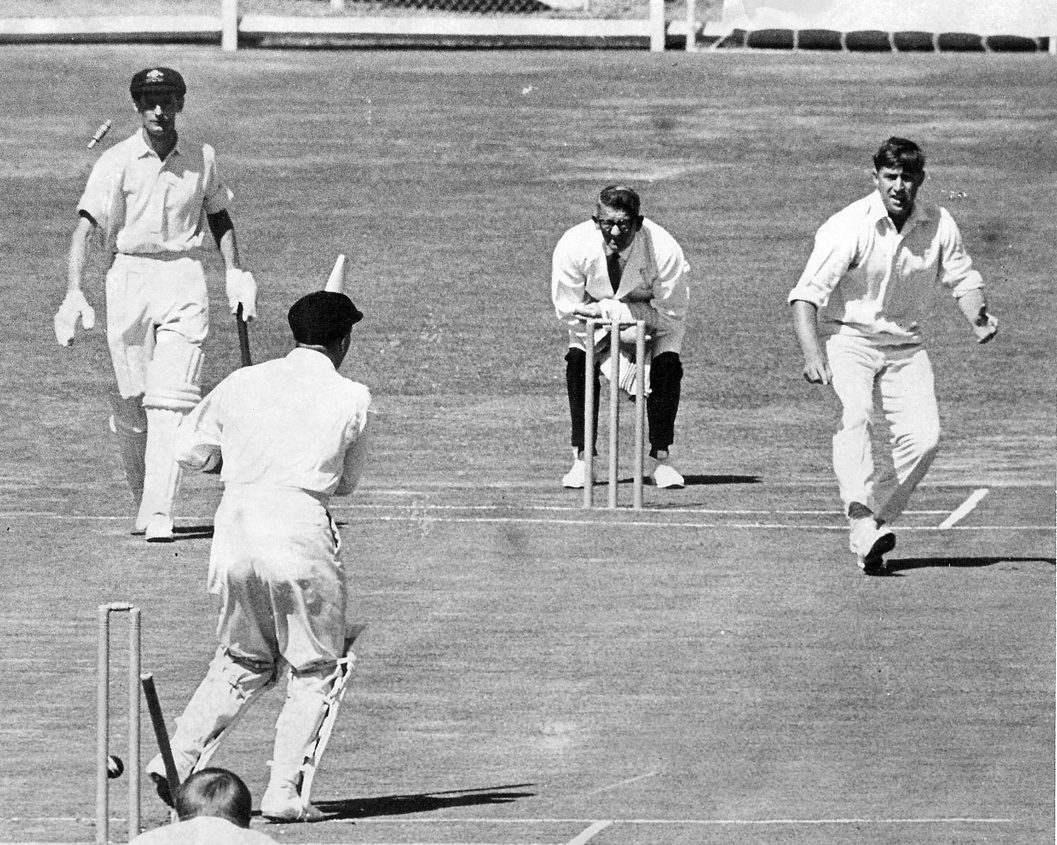

**Canterbury First Class Cricketers**

**Their Career and Achievements**

**Volume 5 1955 to 1968**

**Written and compiled by Brian Adams**